

**Investigating**

**GPA Calculation**

**Key Words**

GPA – Grade point average

GPA scale – The range of numbers on which the GPA is based.

Cumulative GPA – GPA includes all courses throughout high school

Weighted GPA – GPA that includes additional points for Honors and AP level courses

Core GPA – GPA includes only core subjects (math, English, science, and social studies);

Foreign language may be included at some colleges

**Why does GPA matter?**

Indicator – The GPA is a quick indicator of how well the student is performing in his/her classes. Because GPA is based on course grades, it provides a snapshot of what the student has learned as well as how much effort the student invested in his/her classes.

College – GPA plays a very big role in admission to most four-year colleges. Many colleges include GPA as part of their minimum admission requirements.

Scholarships – Many scholarships, offered by the college and by local organizations, have a minimum GPA requirement for consideration. The required GPA is often 2.5, 3.0, or 3.5.

**Huntsville City Schools utilizes a traditional 4.0 GPA scale.**

|  |  |  |  |  |
| --- | --- | --- | --- | --- |
| Grade | Grade Range | Quality Points (regular) | Quality Points (Honors) | Quality Points (AP/IB) |
| A | 90 – 100 | 4.0 | 4.5 | 5.0 |
| B | 80 – 89 | 3.0 | 3.5 | 4.0 |
| C | 70 – 79 | 2.0 | 2.5 | 3.0 |
| D | 60 – 69 | 1.0 | 1.5 | 2.0 |
| F | 0 - 59 | 0.0 | 0.0 | 0.0 |

* If a course is failed and then repeated in summer school, BOTH grades are calculated in the

GPA. The failing grade does not just disappear, and it is not replaced.

* GPA is based on credits earned, so it is recalculated at the end of each school year. (It does change slightly at mid-year if semester courses were taken.)

**Sample transcript – end of 10th grade:**

Course Avg. Credit Course Avg. Credit

English 9 83 B 1.000 English 10 84 B 1.000

Algebra 1 94 A 1.000 Geometry 92 A 1.000

Biology H 88 B 1.000 Chemistry H 83 B 1.000

Human Geography AP 90 A 1.000 World History AP 88 B 1.000

Spanish 1 84 B 1.000 Spanish 2 74 C 1.000

Career Prep 91 A 1.000 Health 79 C 0.500

FdnEngDes 87 B 1.000 D&TSafetyEd 92 A 0.500

LIFE & PE 9-12 79 C 1.000 IntEngDes 93 A 1.000

Psychology 82 B 1.000

|  |  |  |  |
| --- | --- | --- | --- |
| Grade | Number of courses | Weight | Quality Points  (# courses x weight) |
| A | **5.5** | **x** 4 | **22** |
| B | **8** | **x** 3 | **24** |
| C | **2.5** | **x** 2 | **5** |
| D | **-** | **x** 1 | **-** |
| F | **-** | 0 | **-** |
|  |  |  |  |
| AP Courses | **2** | **x** 1 | **2** |
| Honors Courses | **2** | **x** 0.5 | **1** |
|  |  |  |  |
| Total number of courses  | **16** | Total Quality Points  | **54** |

Total Quality Points ÷ Total number of courses = GPA

____**54**____ ÷ ____**16**_____ = ___**3.375**___

**Practice on your own:**

|  |  |  |  |
| --- | --- | --- | --- |
| Grade | Number of courses | Weight | Quality Points  (# courses x weight) |
| A |  | **x** 4 |  |
| B |  | **x** 3 |  |
| C |  | **x** 2 |  |
| D |  | **x** 1 |  |
| F |  | 0 |  |
|  |  |  |  |
| AP Courses |  | **x** 1 |  |
| Honors Courses |  | **x** 0.5 |  |
|  |  |  |  |
| Total number of courses  |  | Total Quality Points  |  |

Total Quality Points ÷ Total number of courses = GPA

GPA calculator

***At the end of your first semester of college, your transcript will look something like this:***

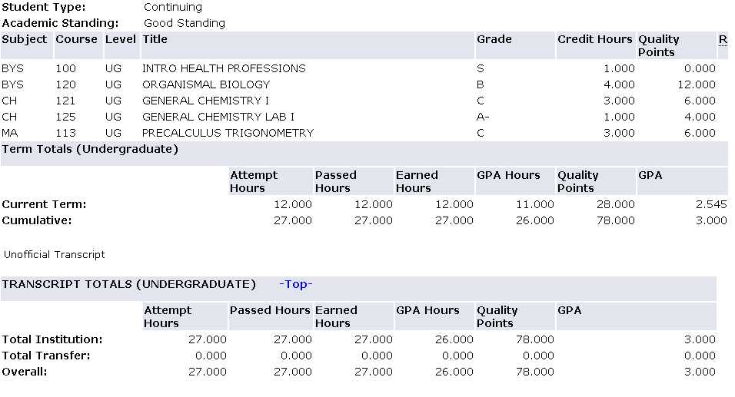

#### GPA = Quality Points / Credit/GPA Hours 78/26 = 3.0

Why does this matter? You need a certain GPA to keep your scholarships

Example: UAH Charger Excellence Scholarship requires:

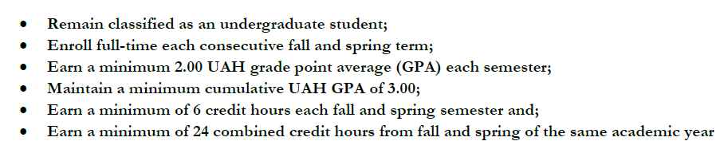

If you know how to calculate your GPA this helps you stay on track or know to get help!

# ***Compute your GPA***

1. Column #1: The courses you are taking this semester.
2. Column #2: The credit hours each course is worth.
3. Column #3: Write your expected grade.
4. Column #4: Write in the multiplier (see below)
5. Column #5: For each row multiply credit hours (#2) by the multiplier (#4) to get the quality points (#5).
6. Add up your totals for #2 and #5.
7. Divide the total #5 total by the #2 total to get your predicted GPA.

|  |  |  |  |  |  |
| --- | --- | --- | --- | --- | --- |
| **#1** | **#2** | **#3** | **#4** | **#5** |  |
| **Course** | **Credit Hours** | **Expected grade** | **Multiplier**  **see below \*** | **Quality points** |  |
| EH 101, English | 3 |  |  |  | **Predicted****GPA****(Quality pts / credit hours)** |
| MA 112,  Precalculus Algebra | 3 |  |  |  |
| FYE 101, First year experience | 1 |  |  |  |
| BYS 119, Biology I | 4 |  |  |  |
| MU 100, Music appreciation | 3 |  |  |  |
|  |  |  |  |  |
|  |  |  |  |  |
|  |  |  |  |  |
| TOTAL |  | ------- | ------- |  |  |

**\*** Multipliers:

|  |  |  |  |  |
| --- | --- | --- | --- | --- |
| **A** = 4.0 | **B** = 3.0 | **C** = 2.0 | **D** = 1.0 | **F** = 0.0 |

***Compute your GPA again but change one grade***

For example, if you predict a B in English 101, change the grade to a C and recalculate your GPA.

**Notice the difference one-letter grade can make!**

# ***Compute your GPA***

1. Column #1: The courses you are taking this semester.
2. Column #2: The credit hours each course is worth.
3. Column #3: Write your expected grade.
4. Column #4: Write in the multiplier (see below)
5. Column #5: For each row multiply credit hours (#2) by the multiplier (#4) to get the quality points (#5).
6. Add up your totals for #2 and #5.
7. Divide the total #5 total by the #2 total to get your predicted GPA.

|  |  |  |  |  |  |
| --- | --- | --- | --- | --- | --- |
| **#1** | **#2** | **#3** | **#4** | **#5** |  |
| **Course** | **Credit Hours** | **Expected grade** | **Multiplier**  **see below \*** | **Quality points** |  |
| EH 101, English | 3 |  |  |  | **Predicted****GPA****(Quality pts / credit hours)** |
| MA 112,  Precalculus Algebra | 3 |  |  |  |
| FYE 101, First year experience | 1 |  |  |  |
| BYS 119, Biology I | 4 |  |  |  |
| MU 100, Music appreciation | 3 |  |  |  |
|  |  |  |  |  |
|  |  |  |  |  |
|  |  |  |  |  |
| TOTAL |  | ------- | ------- |  |  |

**\*** Multipliers:

|  |  |  |  |  |
| --- | --- | --- | --- | --- |
| **A** = 4.0 | **B** = 3.0 | **C** = 2.0 | **D** = 1.0 | **F** = 0.0 |

***Compute your predicted GPA F vs. W***

**Calculate your GPA with one 3 credit course with a grade of F**

|  |  |  |  |  |  |
| --- | --- | --- | --- | --- | --- |
| **#1** | **#2** | **#3** | **#4** | **#5** |  |
| **Course** | **Credit Hours** | **Expected grade** | **Multiplier**  **see below \*** | **Quality points** |  |
| EH 101, English | 3 |  |  |  | **Predicted****GPA****(Quality pts / credit hours)** |
| MA 112,  Precalculus Algebra | 3 |  |  |  |
| FYE 101, First year experience | 1 |  |  |  |
| BYS 119, Biology I | 4 |  |  |  |
| MU 100, Music appreciation | 3 |  |  |  |
|  |  |  |  |  |
|  |  |  |  |  |
|  |  |  |  |  |
| TOTAL |  | ------- | ------- |  |  |

|  |  |  |  |  |
| --- | --- | --- | --- | --- |
| **A** = 4.0 | **B** = 3.0 | **C** = 2.0 | **D** = 1.0 | **F** = 0.0 |
| **Grades of P, S, U, AU, W and I** do not count toward GPA | | | | |

**Calculate your GPA with the same 3 credit course with a grade of W**

|  |  |  |  |  |  |
| --- | --- | --- | --- | --- | --- |
| **#1** | **#2** | **#3** | **#4** | **#5** |  |
| **Course** | **Credit Hours** | **Expected grade** | **Multiplier**  **see below \*** | **Quality points** |  |
| EH 101, English | 3 |  |  |  | **Predicted****GPA****(Quality pts / credit hours)** |
| MA 112,  Precalculus Algebra | 3 |  |  |  |
| FYE 101, First year experience | 1 |  |  |  |
| BYS 119, Biology I | 4 |  |  |  |
| MU 100, Music appreciation | 3 |  |  |  |
|  |  |  |  |  |
|  |  |  |  |  |
|  |  |  |  |  |
| TOTAL |  | ------- | ------- |  |  |